Illinois School f/t Visually Impaired 40th Annual

Parent Infant/Opening Doors Program

#175 Years of Change

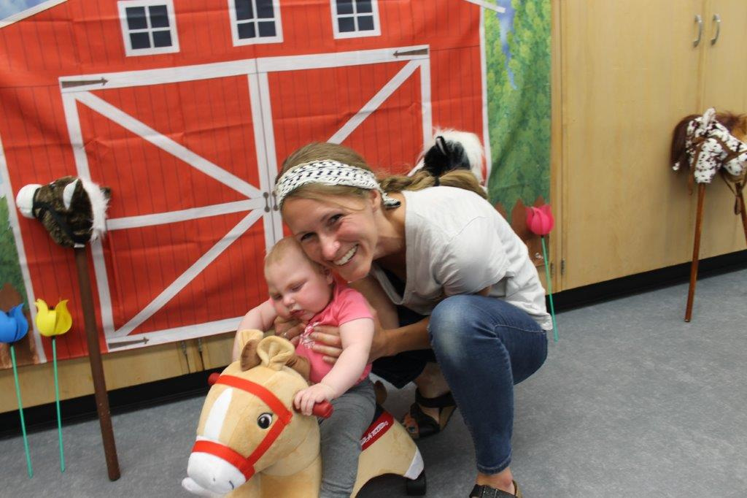
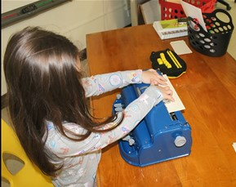  What is Opening Doors?  The Opening Doors conference is a multiday event for caregivers and their children with vision loss ages birth to five. |  |  | Registration Link:  https://forms.gle/eAo2C7c5BZeZgoaS6  When: June 7-10, 2023  Where: ISVI Campus/Jacksonville  Register Now! A maximum of 25 families will be accepted.  We look forward to seeing everyone back in person!!

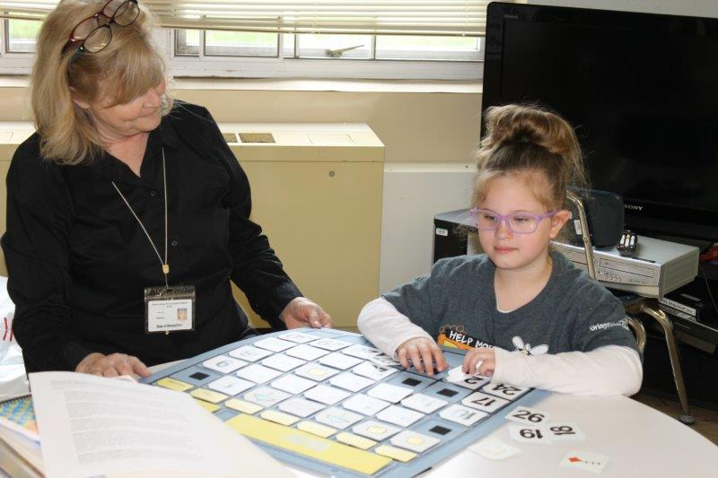 |  |  |  |  |  | Doors to Education:  - Early Literacy  - Braille  - Cortical Visual Impairment  - Advocacy  - Friendships and Children  - Sensory Processing  - Technology  - Feeding Skills  - Panel Discussions  Doors to Exploration:  - Parent Networking Opportunities  - Small Child classroom groupings with an educator.  - ISVI campus tours available  - Workshops and group discussions for parents.  - Programing for siblings ages five and under  - Consultation available in Orientation and Mobility and Functional Vision.
Mission Statement  The mission of Opening Doors is to provide support to families of infants and toddlers who are blind or visually impaired to assist them in making informed decisions on behalf of their child, and to provide information on their child based on observation and assessment.  Contact:  Michelle Clark/Outreach Director  Michelle.clark@illinois.gov  Illinois School f/t Visually Impaired  658 E State St  Jacksonville IL 62650  isvi.illinois.gov |  |  | I loved my time at the in-person event in Jacksonville! All the staff members were so helpful and loving on our daughter. I left very encouraged.

